**Name : Rohit Phatangare.**

**Roll No. : MCA2023044.**

**Seat No.:9302464.**

**Assignment 1**

1. **Print Today’s date and time using REPL.**

**Repl.js**

const now = new Date();

const CurrentDate = now.toLocaleDateString();

const CurrentTime = now.toLocaleTimeString();

console.log("Today's date: ", CurrentDate);

console.log("Current time: ", CurrentTime);

**Output:**



1. **Write a program to Print the given pattern**

**12345**

**1234**

**123**

**12**

**1**

**Pattern.js :**

for (let i = 5; i >= 1; i--) {

  let pattern = "";

  for (let j = 1; j <= i; j++) {

    pattern = pattern + j;

  }

  console.log(pattern);

}

**Output : -**

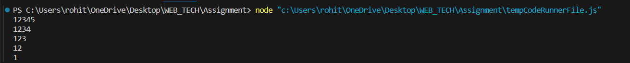

**Assignment 2**

**a) Print &quot;Hello&quot; every 500 milliseconds using the Timer Module. The message should be printed exactly 10 times. Use SetInterval ,ClearInterval and SetTimeout methods**.

**Input.js**

let count = 0;

const printHello = () => {

    console.log("Hello");

    count++;

    if (count === 10) {

        clearInterval(intervalId);

    }

};

const intervalId = setInterval(printHello, 500);

setTimeout(() => {

    clearInterval(intervalId);

}, 5000);

Output : -

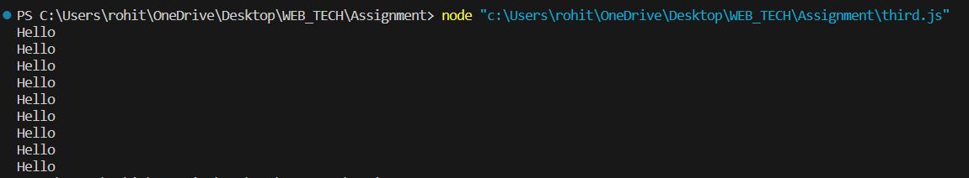

**Assignment 3**

**A ) Create a circle module with functions to find the area and perimeter of a circle and use it.**

**cicleModule.js :**

const calculateArea = (radius) => {

    return Math.PI * Math.pow(radius, 2);

};

const calculatePerimeter = (radius) => {

    return 2 * Math.PI * radius;

};

module.exports = {

    calculateArea,

    calculatePerimeter

};

**Main.js :**

const circleModule = require('./circlemodule');

const radius = 5;

const area = circleModule.calculateArea(radius);

console.log(`Area of the circle with radius ${radius} : ${area.toFixed(2)}`);

const perimeter = circleModule.calculatePerimeter(radius);

console.log(`Perimeter of the circle with radius ${radius} : ${perimeter.toFixed(2)}`);

**Output :**



**Assignment 4**

**a) Create an application using Filters-Uppercase and Lowercase Filters, Currency and Number**

**Formatting Filters,OrderBy Filter,**

**Create an Array to store the information of 5 employees(empid,name,salary,doj) and apply**

**relevant filters to**

**i) convert name to uppercase**

**ii) apply currency and number filter**

**iii) order by**

**Input.html: -**

<!DOCTYPE html>

<html lang="en">

<head>

    <meta charset="UTF-8" />

    <meta name="viewport" content="width=device-width, initial-scale=1.0" />

    <title>Application</title>

    <script src="https://ajax.googleapis.com/ajax/libs/angularjs/1.8.2/angular.min.js"></script>

</head>

<body>

    <div ng-app="myApp" ng-controller="myCtrl">

        <label>

            List Of Employes Order by Salary :

            <select ng-model="orderBy" ng-change="sortData()">

                <option value="desc">Descending</option>

                <option value="asc">Ascending</option>

            </select>

        </label>

        <br />

        <label>

            Change Name Style :

            <select ng-model="caseBy" ng-change="convertCase()">

                <option value="">Select</option>

                <option value="upper">Upercase</option>

                <option value="lower">Lowecase</option>

            </select>

        </label>

        <label>

            <br />

            Change Number to Currency :

            <select ng-model="conversionBy" ng-change="formatCurrency()">

                <option value="">Select</option>

                <option value="num">Number</option>

                <option value="cur">Currency</option>

            </select>

        </label>

        <table border="1">

            <tbody>

                <tr ng-repeat="employee in employees | orderBy:'salary':(orderBy ==='desc')">

                    <td>{{employee.empid}}</td>

                    <td>{{employee.name}}</td>

                    <td> {{employee.salary}}</td>

                    <td>{{employee.doj}}</td>

                </tr>

            </tbody>

        </table>

    </div>

    <script>

        angular.module("myApp", []).controller("myCtrl", function ($scope) {

            $scope.employees = [

                { empid: 1, name: "ROHIT", salary: 6000, doj: "01-02-2022" },

                { empid: 2, name: "DEVANK", salary: 2000, doj: "29-08-2020" },

                { empid: 3, name: "ANKIT", salary: 1000, doj: "5-12-2015" },

                { empid: 4, name: "YASH", salary: 8000, doj: "10-09-208" },

                { empid: 5, name: "YUVA", salary: 9000, doj: "16-03-2014" },

            ];

            //$scope.orderBy = "asc";

            $scope.sortData = function () {

                if ($scope.orderBy === "desc") {

                    $scope.employees.reverse();

                }

            };

            $scope.convertCase = function () {

                angular.forEach($scope.employees, function (employee) {

                    employee.name =

                        $scope.caseBy === "upper"

                            ? employee.name.toUpperCase()

                            : employee.name.toLowerCase();

                });

            };

            $scope.formatCurrency = function () {

                angular.forEach($scope.employees, function (employee) {

                    employee.salary =

                        $scope.conversionBy === "num"

                            ? employee.salary

                            : employee.salary;

                });

            };

        });

    </script>

</body>

</html>

**Output :-**

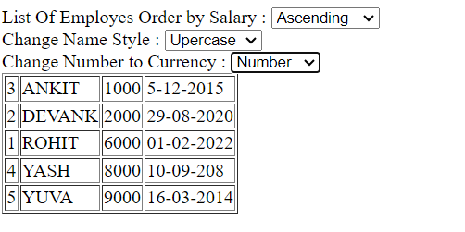

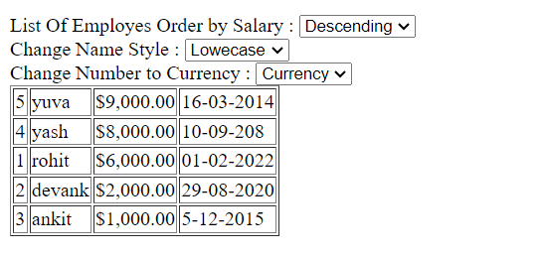

**Assignment 5**

**Demonstrate features of Angular.js forms with a program**

**Create a registration form for a college event containing fname, lName,gender, class, dept, type of event, contact, email .Put validation, on button click display**

**Input.html :-**

<head>

    <title>

        AngularJs Form Input Fields Validation Example using CSS class </title>

    <script src="https://ajax.googleapis.com/ajax/libs/angularjs/1.8.2/angular.min.js"></script>

    <script>

        var app = angular.module('formApp', []); app.controller('formCtrl', function ($scope) {

            $scope.sendForm = function () {

                $scope.msg = 'Thank You ,  Your Form Is Submited Successfully';

            };

            $scope.getClass = function (color) {

                return color.toString();

            }

        });

    </script>

    <style>

        .valid.false {

            background: red;

        }

        .valid.true {

            background: green;

        }

        .error {

            color: red;

        }

    </style>

</head>

<body ng-app="formApp" ng-controller="formCtrl">

    <h3>Form validation by using CSS in AngularJs</h3>

    <form name="personForm" ng-submit="sendForm()">

        <label for="name">First Name</label>

        <input id="fname" name="name" type="text" ng-model="person.fname" required />

        <span class="error" ng-show="personForm.name.$error.required"> Required! </span>

        <br />

        <br />

        <label for="name">Last Name</label>

        <input id="lname" name="name" type="text" ng-model="person.lname" required />

        <span class="error" ng-show="personForm.name.$error.required"> Required! </span>

        <br />

        <br />

        <label for="name">Gender : </label>

        <select name="" id="">

            <option value="">Select</option>

            <option value="">Male</option>

            <option value="">Female</option>

            <option value="">Other</option>

        </select>

        <br>

        <br>

        <label for="class">Class : </label>

        <input id="class" name="address" type="text" ng-model="person.class" required />

        <span class="error" ng-show="personForm.class.$error.required"> Required! </span>

         <br />

         <br />

        <label for="depart">Department : </label>

        <input id="depart" name="address" type="text" ng-model="person.depart" required />

        <span class="error" ng-show="personForm.depart.$error.required"> Required! </span>

         <br />

         <br />

        <label for="event">Type Of Event : </label>

        <input id="event" name="address" type="text" ng-model="person.event" required />

        <span class="error" ng-show="personForm.event.$error.required"> Required! </span>

         <br />

         <br />

        <label for="contact">Contact</label>

        <input id="mobile" name="mobile" type="number" ng-model="person.mobile" required />

        <span class="error" ng-show="personForm.mobile.$error.required">Required number!</span>

        <span class="error" ng-show="personForm.mobile.$error.mobile">Invalid mobile!</span>

        <br />

        <br />

        <label for="email">Email</label>

        <input id="email" name="email" type="email" ng-model="person.email" required />

        <span class="error" ng-show="personForm.email.$error.required">Required!</span>

        <span class="error" ng-show="personForm.email.$error.email">Invalid Email!</span>

        <br />

        <br />

        <input type="checkbox" ng-model="terms" name="terms" id="terms" required />

        <label for="terms">I Agree to the terms.</label>

        <span class="error" ng-show="personForm.terms.$error.required">You must agree to the terms</span>

        <br />

        <br />

        <button type="submit">Submit Form</button>

        <br />

        <br />

        <h3>Registration Confimation.</h3>

        <span>{{msg}}</span>

    </form>

</body>

</html>

**Output : -**

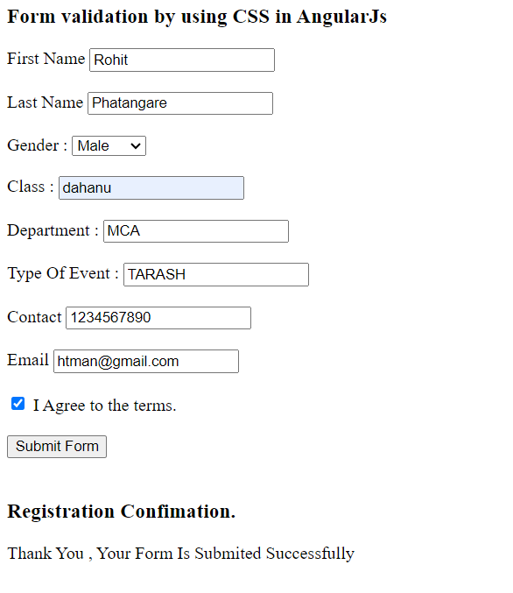

**Assignment 6**

**Create an application to demonstrate mouse and keyboard directive**

**Input.html :-**

<!DOCTYPE html>

<html lang="en" ng-app="eventDemoApp">

<head>

    <meta charset="UTF-8">

    <title>AngularJS Event Directives Demo</title>

    <script src="https://ajax.googleapis.com/ajax/libs/angularjs/1.8.2/angular.min.js"></script>

    <style>

        body {

            font-family: Arial, sans-serif;

            text-align: center;

        }

        .event-container {

            margin: 50px;

            padding: 20px;

            border: 1px solid #ccc;

            cursor: pointer;

        }

    </style>

</head>

<body ng-controller="eventDemoController">

    <h2>AngularJS Event Directives Demo</h2>

    <div class="event-container"

         ng-mouseenter="onMouseEnter()"

         ng-mouseleave="onMouseLeave()"

         ng-click="onClick()"

         ng-keypress="onKeyPress($event)"

         tabindex="0">

        Hover over, click, or press a key inside this box.

    </div>

    <div>

        <p><strong>Mouse Events:</strong> {{ mouseEvent }}</p>

        <p><strong>Click Event:</strong> {{ clickEvent }}</p>

        <p><strong>Key Press Event:</strong> {{ keyPressEvent }}</p>

    </div>

    <script>

        var app = angular.module('eventDemoApp', []);

        app.controller('eventDemoController', function($scope) {

            $scope.mouseEvent = '';

            $scope.clickEvent = '';

            $scope.keyPressEvent = '';

            $scope.onMouseEnter = function() {

                $scope.mouseEvent = 'Mouse Enter';

            };

            $scope.onMouseLeave = function() {

                $scope.mouseEvent = 'Mouse Leave';

            };

            $scope.onClick = function() {

                $scope.clickEvent = 'Click';

            };

            $scope.onKeyPress = function(event) {

                $scope.keyPressEvent = 'Key Press: ' + String.fromCharCode(event.which);

            };

        });

    </script>

</body>

</html>

**Output :-**

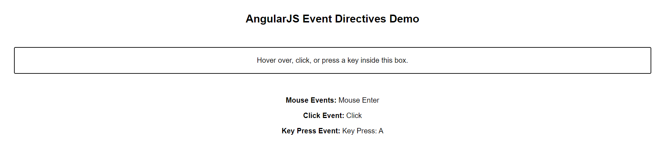

**Assignment 7**

**Create a SPA (Single Page Application)**

**spa.html :-**

<!DOCTYPE html>

<html lang="en" ng-app="navbarApp">

<head>

    <meta charset="UTF-8">

    <title>AngularJS SPA</title>

    <script src="https://ajax.googleapis.com/ajax/libs/angularjs/1.8.2/angular.min.js"></script>

    <link rel="stylesheet" href="style.css">

</head>

<body ng-controller="navbarController">

    <div class="navbar">

        <a href="home.html">Home</a>

        <a href="about.html">About</a>

        <a href="contact.html">Contact</a>

    </div>

<h1>This Is Single Page Application . </h1>

</body>

</html>

**home.html :**

<html>

<script src="https://ajax.googleapis.com/ajax/libs/angularjs/1.8.2/angular.min.js"></script>

<body>

    <div ng-app="">

        <h1>This Is Home Page 😊</h1>

        <br>

        <br>

    </div>

    <button><a href="spa.html"> BACK </button>

</body>

</html>

**about.html :**

<html>

<script src="https://ajax.googleapis.com/ajax/libs/angularjs/1.8.2/angular.min.js"></script>

<body>

    <div ng-app="">

        <h1>This is About Page 😊</h1>

        <br><br>

    </div>

    <button><a href="spa.html"> BACK </button>

</body>

</html>

**contact.html :**

<html>

<script src="https://ajax.googleapis.com/ajax/libs/angularjs/1.8.2/angular.min.js"></script>

<body>

    <div ng-app="">

        <h1>This Is Contact Page 😊</h1> <br><br>

    </div>

    <button><a href="spa.html"> BACK </button>

</body>

</html>

**Output :**





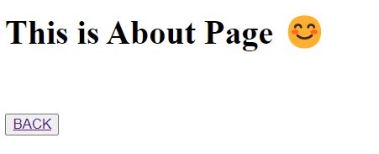



**Assignment 8**

**Create an application to demonstrate directives Style**

**Input.html:-**

<!DOCTYPE html>

<html lang="en" ng-app="styleApp">

<head>

    <meta charset="UTF-8">

    <title>AngularJS Directives - Styling</title>

    <script src="https://ajax.googleapis.com/ajax/libs/angularjs/1.8.2/angular.min.js"></script>

    <style>

        .highlight {

            background-color: yellow;

        }

        .text-danger {

            color: red;

            font-weight: bold;

        }

    </style>

</head>

<body ng-controller="styleController">

    <h2>AngularJS Directives - Styling</h2>

    <div>

        <label>Toggle Highlight:</label>

        <input type="checkbox" ng-model="highlightToggle">

    </div>

    <div ng-class="{ 'highlight': highlightToggle }">

        This div is highlighted based on the checkbox state.

    </div>

    <br>

    <div>

        <label>Enter Danger Zone:</label>

        <input type="text" ng-model="dangerInput">

    </div>

    <div ng-class="{ 'text-danger': dangerInput === 'danger' }">

        This text turns red and bold when you type 'danger'.

    </div>

    <br>

    <div>

        <label>Change Text Color:</label>

        <input type="color" ng-model="textColor">

    </div>

    <div ng-style="{ 'color': textColor }">

        This text changes color based on the color input.

    </div>

    <script>

        var app = angular.module('styleApp', []);

        app.controller('styleController', function($scope) {

            $scope.highlightToggle = false;

            $scope.dangerInput = '';

            $scope.textColor = '#000000';

        });

    </script>

</body>

</html>

**Output :-**

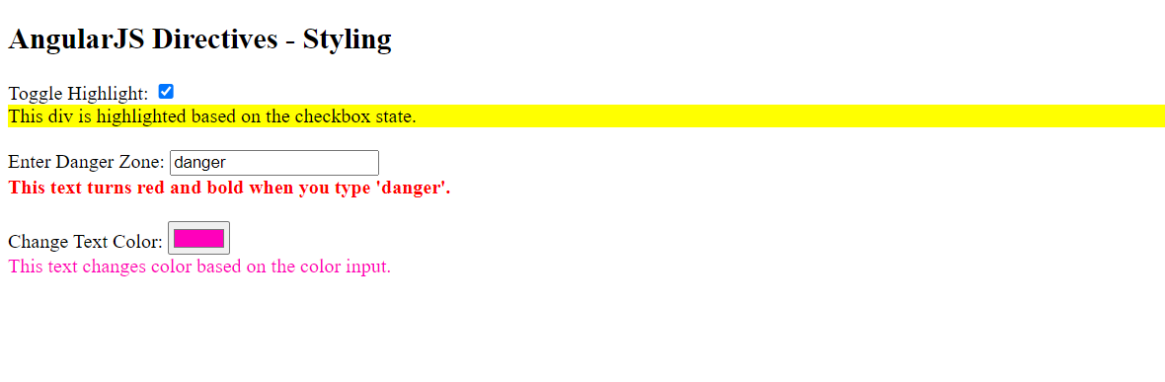

**Assignment 9**

**Create an application to establish a connection with the MySQL database and perform basic**

**database operations on it(student db consisting rollno,name,address),insert 10 records, update a particular student’s record, and later on delete a record.**

**Connection.js**

var mysql = require("mysql");

var con = mysql.createConnection({

  host: "localhost",

  user: "root",

  password: "",

});

con.connect(function (err) {

  if (err) throw err;

  console.log("Connected");

  con.query("CREATE DATABASE student", function (err, result) {

    if (err) throw err;

    console.log("DATABASE CREATED");

  });

});

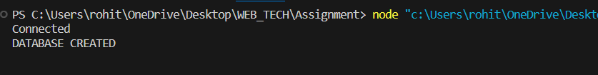

**Create.js**

var mysql = require("mysql");

var con = mysql.createConnection({

  host: "localhost",

  user: "root",

  password: "",

  database: "student",

});

con.connect(function (err) {

  if (err) throw err;

  console.log("Connected");

  var createTableQuery =

    "CREATE TABLE info (" +

    "STUDENT_ROLLNO INT(10)," +

    "STUDENT_NAME VARCHAR(20)," +

    "STUDENT_ADDRESS VARCHAR(15)" +

    ")";

  con.query(createTableQuery, function (err, result) {

    if (err) throw err;

    console.log("TABLE CREATED");

  });

});

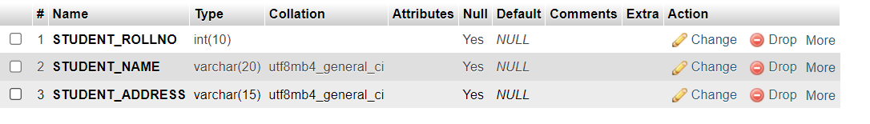

**Insert.js**

var mysql = require("mysql");

var con = mysql.createConnection({

  host: "localhost",

  user: "root",

  password: "",

  database: "student",

});

con.connect(function (err) {

  if (err) throw err;

  console.log("Connected");

  var sql =

    "INSERT INTO info (STUDENT_ROLLNO,STUDENT_NAME,STUDENT_ADDRESS) VALUES ?";

  var values = [

    [1, "ROHIT", "Dahanu"],

    [2, "SURAJ", "Mumbai"],

    [3, "Ankit", "Pune"],

    [4, "Devank", "Kurla"],

    [5, "Yash", "Kalyan"],

    [6, "Shreyash", "Chiplunyan"],

    [7, "Mukesh", "Kerla"],

    [8, "Yuva", "UP"],

    [9, "Saburi", "Bihar"],

    [10, "Bhuvan", "Delhi"],

  ];

  con.query(sql, [values], function (err, result) {

    if (err) throw err;

    console.log("Numbers of record inserted: " + result.affectedRows);

  });

});

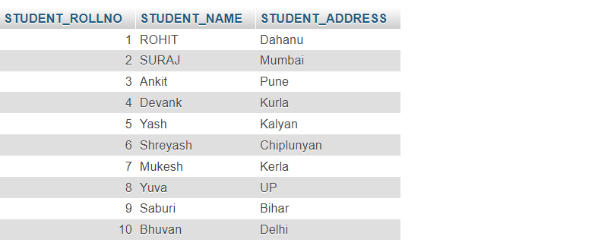

**Update.js**

var mysql = require("mysql");

var con = mysql.createConnection({

  host: "localhost",

  user: "root",

  password: "",

  database: "student",

});

con.connect(function (err) {

  if (err) throw err;

  console.log("Connected");

  con.query(

    "UPDATE info SET STUDENT_NAME='Surya',STUDENT_ADDRESS='Kashmir' WHERE STUDENT_ROLLNO=2",

    function (err, result) {

      if (err) throw err;

      console.log("Record Updated");

    }

  );

});

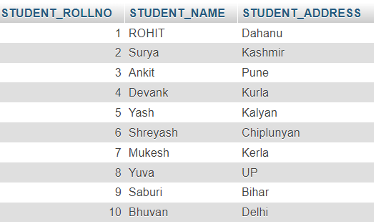

**Delete.js**

var mysql = require("mysql");

var con = mysql.createConnection({

  host: "localhost",

  user: "root",

  password: "",

  database: "student",

});

con.connect(function (err) {

  if (err) throw err;

  console.log("Connected");

  con.query(

    "DELETE FROM info WHERE STUDENT_ROLLNO IN (2,4)",

    function (err, result) {

      if (err) throw err;

      console.log("Record Deleted");

    }

  );

});

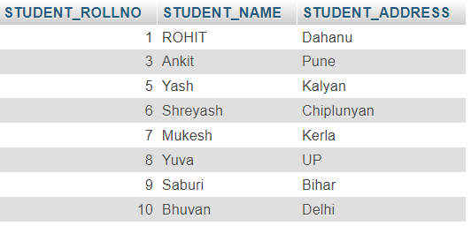

**Assignment 10**

**create a Calculator Node.js Module with functions add, subtract and multiply,Divide. And use the Calculator module in another Node.js file.**

**Cal.js:-**

exports.add = function (x, y) {

  return x + y;

};

exports.sub = function (x, y) {

  return x - y;

};

exports.mul = function (x, y) {

  return x * y;

};

exports.div = function (x, y) {

  return x / y;

};

**Usingmodule.js**

var cal = require('./Cal');

var x = 500;

var y = 100;

console.log("Adddition=", cal.add(x, y));

console.log("Subtraction=", cal.sub(x, y));

console.log("Multiplication=", cal.mul(x, y));

console.log("Divison=", cal.div(x, y));

**output :**

